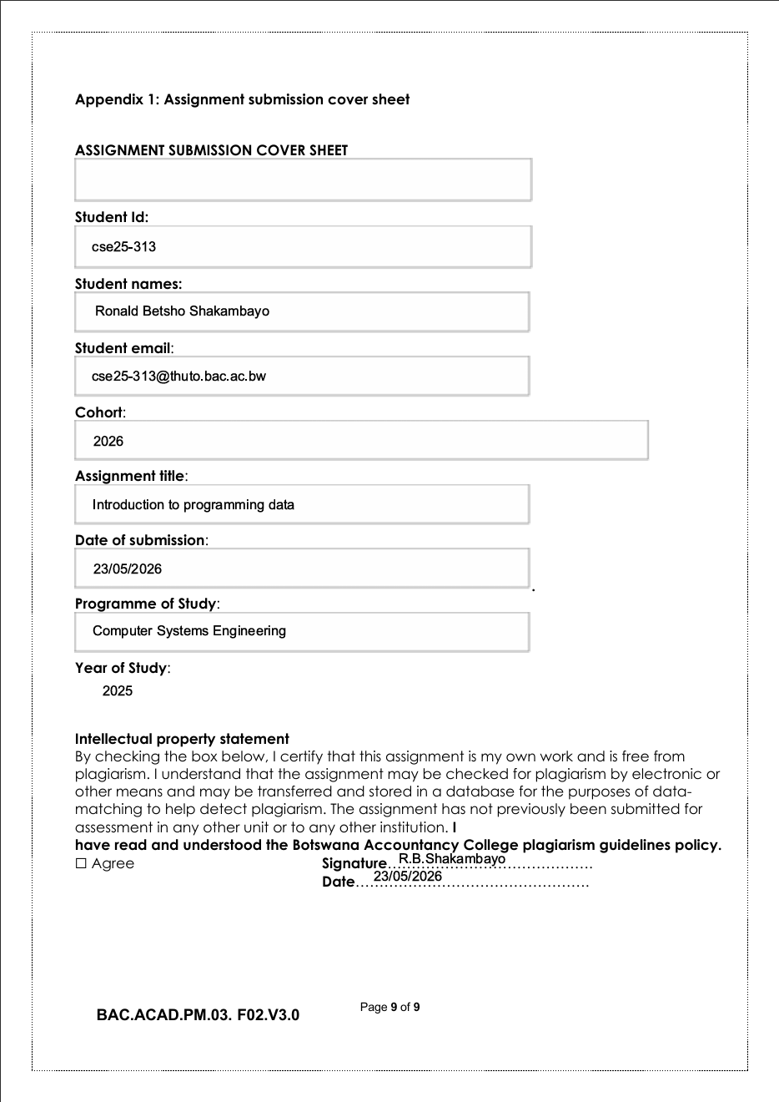

THE BMW NATION
Introduction
This website is designed to showcase BMW as a leading global automotive brand known for its luxury, performance, and innovation. It provides essential information about BMW’s unique driving experience its vehicles offer and its special luxury Specs. Overall the purpose of this site is to inform visitors, users and promote understanding of BMW as a premium vehicle manufacturer.

Website Specifications
Website Objective
This website is designed to showcase BMW cars and their specifications.
Goals
- Browse through vehicles available within the website
- View vehicle details (model, engine type & features)
- Alert users about the website (The website is about showcasing BMW models)
- Contact the dealership
Target Audience
- Age group: 16 years and upwards
- Interests: Users must be interested in luxury vehicles, High performance vehicles
- Technical ability: Average users who can browse online easily/ basic moderate internet users.
- Location: Botswana, Gaborone Block 8
Website Type
- Informational Website: The website intents to educate, raise awareness and inform users about BMW cars, new models and their special features.

BMW Nation Citing and Paraphrasing.
Brand Identity
BMW is widely known for combining luxury, performance, and advanced engineering. Its reputation is built on producing high-quality vehicles that meet global standards of innovation and precision (Car Visionary, 2025).
Performance & Driving Experience
BMW vehicles are designed to provide a superior driving experience, offering balance of power, comfort, and precise handling, which makes them enjoyable to drive (BimmerBoom,2026)
BMW in Botswana
In Botswana, BMW vehicles are available through Capital Motors, the official dealership that provides vehicle sales, servicing, and support to customers (AutoYas,2026).

- AutoYas (2026) Capital Motors Botswana.
Available at: https://www.autoyas.com

- BimmerBoom (2026) What is BMW best known for.
Available at: https://bimmerboom.com

- Car Visionary (2025) BMW performance and innovation.
Available at: https://carvisionary.net

Information Design and Taxonomy

Description

Home Page: The top-level page from which all other sections originate.
The Home page links to:
- About us
- Contact us
- Cars
- Customer Feedback

About us:
Here the users informed what the website is all about like the mission and goal etc.
Contact us:
In this page the user can contact BMW Nation for any questions or requests they have through WhatsApp, Email or fill the Contact Form.
Cars:
This page is where the BMW models are shown and their specifications.
Feedback:
In this page users of the website will give feedback to web developer and other users with ratings.

Technical Brief
The BMW NATION dealership website will be developed using modern Web technologies to ensure it is functional, responsive and user friendly.
HTML5 will be used to structure the website and define the layout of each webpage, for styling, design and visual appearance CSS3 will be used.
JavaScript will used to add interactivity for features such as form validation (e.g. booking a test drive) and dynamic content updates. The website will also use Bootstrap to ensure it is responsive and accessible across different devices such as smartphones, tablets and desktops.
For development and version control, GitHub will be used to store and manage the website files. The website will be published online using GitHub Pages allowing users to access it using web link.
Images of vehicle for display in the gallery and listing as an additional resource.

Homepage Template

BMW NATION Logo

Home| About us| Contact us| Cars |Feedback
Price: P950,000
Engine: 3.0L Twin Turbo S58
Horsepower: 503 hp @ 7,200rpm 6,250rpm

BMW M3 Competition Picture

gggpicture
Explore Models
Discover performance, luxury, and innovation in every BMW model mmomodel
Explore BMW Excellence
Welcome to BMW Nation
BMW NATION
Copyright @ BMW NATION Dealership | Legal | Privacy Policy
About-us page Template

Home| About us| Contact us| Cars | Feedback
BMW NATION LOGO

BMW NATION

About BMW Nation

Our Vision
Content

Our Mission
Content

Why BMW Nation
Content

What We Showcase
Content

Copyright @ BMW NATION Dealership| Legal | Privacy Policy

Contact-us Page Template

BMW NATION

BMW NATION LOGO
Get in Touch
Contact us

Home| About us| Contact us| Cars | User Feedback

Contact Form

Address
 Phone
Phone number
WhatsApp
WhatsApp number
Email
The email

Name

Email

Phone

Message

Send Message

Copyright @ BMW NATION Dealership| Legal| Privacy Policy

Cars Page Template
Next >
3
2
1
< Previous
BMW Model
Price: XXXXX
Year | Engine
Image Placeholder
Electrice
Price: XXXXX
Year | Engine
BMW Model
Image Placeholder
BMW Model
SUV
Sedan
Image Placeholder
Coupe
BMW Model
Year | Engine
Price: XXXXX
Price: XXXXX
BMW Model
Year | Engine

Image Placeholder
Copyright @ BMW NATION Dealership | Legal | Privacy Policy
Request Full info
Request full info
Request full info
Request full info

Home| About us| Contact us| Cars | Feedback
3
BMW NATION LOGO
BMW NATION
The ultimate Driving Experience
Copyright @ BMW NATION Dealership | Legal | Privacy Policy
Submit
Phone
Address
Email
Full Names
Booking Form

Feedback

Home| About us| Contact us| Cars for Sale| Book Test Driver
BMW NATION
The ultimate Driving Experience

BMW NATION LOGO

